Framework for Risk in the Community Chat with young people. | 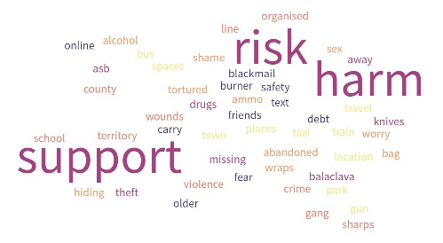
Consent for Risk in the Community Chat to be shared.
Name of Young Person:
- I understand what I am taking part in.

- I am happy to take part and know that I can ask for the chat to end whenever I want it to.

- I know that if I describe things that mean I or other people are not safe then the social work team will be asked to offer support. I will be told if this should happen.

I understand that the notes made during this chat will:

- Be uploaded onto my records within Social Care so that my Social Worker and other professionals know how I feel.

- Inform professionals understanding about young people’s experiences of missing and that my name will not be mentioned.

I want to take part in the Risk in the Community Chat because (optional):

Signed:

Today’s date:

Topic 1: What is happening at home? (Push)
1. Tell me what’s been going on and how things are:
Are there reasons that you do not feel happy at home? What are these?

2. Who is safe for you to talk to at home?
Family/extended family

Topic 2: Peer Relationships/Friendships (Pull)
Who do you spend time with?

How did you know them?

How long have you known them?

Who in your friendship groups do you feel safe with? Why?

Who in your friendship groups do you not feel safe with? Why?

Do your family know who your friends are? If not, why?

What do your friends bring to your friendships? (Loyalty, laughter, fun, risk, adrenaline, drugs)

Do your friends all live near to you?

Do you have online friends that you haven’t met yet?

Is there anyone you worry about (friends, adults)?

Does anyone pressure you to stay friends with them?

Topic 3: Places/Spaces
1. Locations / Travel
Where do you go when you are not at home?

Which Towns/cities/villages do you go to the most?

In those places, what Parks/town centre/ blocks do you spend time in?

Places you feel safe in the community?

Why?

Places you don’t feel safe in the community?

Why?

Locations/spaces you make a point to avoid?

What needs to change for you to feel safer when you are out with friends?

What is the scariest thing you have been a part of whilst you have been with friends and where?

2. What school, college or training do you go to if any?

3. Do you feel you have an adult to talk to now about problems or worries?
Would you talk to a police officer?

Next Steps: Key issues and actions
- What do you feel people have been doing to help you stay safe when you leave the home and are with friends in the community? (phone/location alert/tracking)? Are you happy with this?

- What do you think needs to change to help you be safer?
Worries | Action | Who

- Do you know where to go for help and advice?

Information given:

Important relationships:
This circle is about exploring relationships. Start by putting yourself in the centre circle and the people you have relationships with around you, the closer they are to you, the closer the relationship they have with you. You don’t have to put their names if you prefer you can just say what the relationship is and use initials.


Locations:
Towns:

Spaces: (parks etc)

Travel: (train/bus etc)

Time of Day:

Known Risks: (weapons/ASB/Drugs)

