**Operation Makesafe – Impact Log 23.06.2025**

|  |  |
| --- | --- |
| **Place** |  |
| **Time** |  |

**Discussions with staff (state how many below):**

|  |  |
| --- | --- |
| Hotel staff |  |
| Leisure venue staff |  |

**Discussions with public (state how many below):**

|  |  |
| --- | --- |
| Young people |  |
| Adults |  |

**Any conversation highlights?**

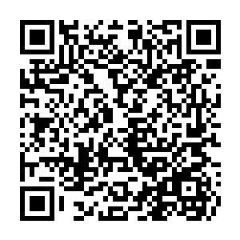

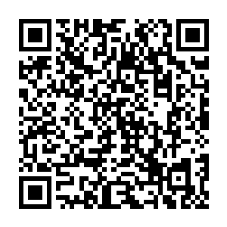Please fill out your online return using [this link](https://consultations.essex.gov.uk/esab/4a013444) or QR code.

It should only take a few minutes 😊 Thank you!