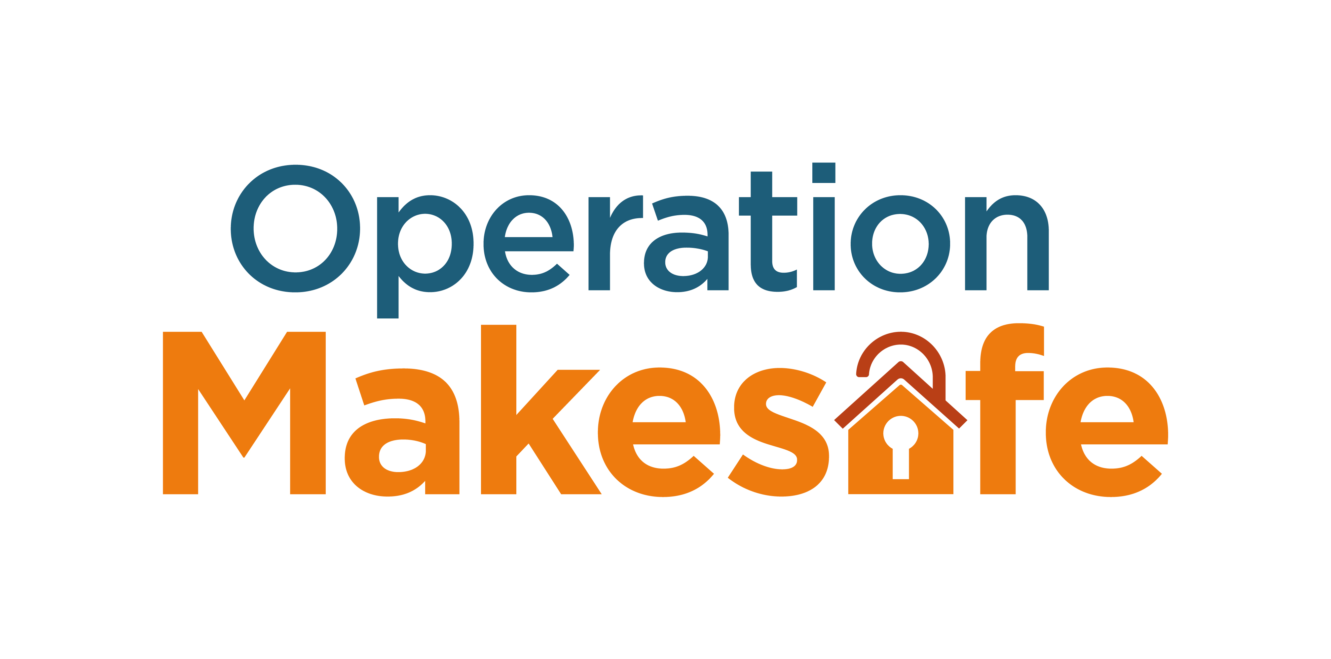

Dear Premises Manager,

**RE: Campaign to Tackle Exploitation of Children and Young People**

**Operation Makesafe is a countrywide initiative to raise awareness of the exploitation of children and young people that can occur in the hotel/leisure business areas.**

Following the findings of the Rotherham enquiry (1997 - 2013) and Rochdale enquiry (2018) where it was identified that child exploitation took place within settings such as hotels, we are actively seeking to raise the awareness of the exploitation of children and young people across all hotels in the county of Essex, as we know this can still happen. The exploitation and trafficking of children and young people can involve all sorts of licensed premises, including yours. You have the power to help us to prevent Child Exploitation (CE), including criminal, sexual exploitation, and trafficking.

**Please act now:**

We are writing to you because we believe that local businesses can play a positive role in preventing CE, which puts children, young people, and your business, at risk. Children and young people may become involved in criminality at your premises, for example sexual exploitation of children and young people, illegal drug use and dealing etc. This behaviour should not always be viewed as anti-social behavior but should in some cases be seen as a vulnerability factor and an indicator that they may be involved in CE. We want to work with you to ensure that your business is not vulnerable to being associated with these crimes which are particularly targeted at children and young people.

**What is CE?**

Child exploitation is a type of abuse and refers to the use of children and young people for someone’s advantage, gratification or profit often resulting in unjust, cruel, and harmful treatments to the victim. Children and young people can be exploited in many ways, including being trafficked, criminally and/or sexually exploited. Some examples are as follows:

* Where young people under 18 are encouraged, trapped, forced, or coerced into a sexual relationship by an adult.
* It involves young people being offered something in return for performing sexual or criminal acts.
* Young people being used to sell drugs.
* Alcohol, cigarettes, mobile phones, gifts, money, drugs, love – may all be offered in return.

**Where does it happen?**

Children and young people can be groomed and exploited at a variety of premises and locations such as: parks, shopping centers, taxi ranks, restaurants, takeaways, gyms, leisure centers, hotels, and pubs and bars.

**The Law**

It is the responsibility of premises license holders and their managers to make sure that suitable control measures are in place at licensed venues for the protection of children from harm. This is a legal requirement under the Licensing Act 2003.

Failure to comply with your legal obligations can lead to consequences such as:

* Financial or reputational damage.
* Revocation of license.
* Prosecution.

Whilst you may not necessarily be a licensed establishment, safeguarding is everyone’s responsibility, and you need to ensure that your establishment works in a way that prevents and protects children and young people from child exploitation.

If these activities are taking place within your establishment and there’s a failure to make the relevant agencies aware, you may be subject to enforcement action.

**Say Something if you See Something**

All staff working in your hotels should be alert to the following:

* Young male or female checking in with a significantly older adult.
* Guest insists on paying in cash, not leaving credit card imprint.
* Multiple adults and young people checking into rooms.
* A person who looks fearful, nervous, withdrawn, or uncomfortable.
* Teenagers loitering in reception or corridors.
* Frequent visitors with no apparent reason for being in the hotel.
* Guests who are in and out of the hotel at irregular hours.
* Noise complaints.
* Last-minute walk-in bookings.
* Guests requesting rooms which are isolated.
* Guests with a local address renting room.
* Guest rooms being left with evidence of a lot of condoms, drug paraphernalia e.g. syringes, wraps, pipes, bongs, broken light bulbs, spoons, plastic bags.
* High traffic to one guest room.
* Guests ask for a specific room number but not knowing the name it’s booked in.
* Guests arrive with no luggage.
* Guests who do not want their rooms cleaned.
* Guests who appear to be under 25 – checking for ID for alcohol in either rooms or in licensed area.
* Two or more males heading to the same room.
* Men visiting the same room at regular intervals.
* Young girls appear to be overly made up.
* Guests use excessive or unusual amounts of pornography on TV.
* Individuals monitoring public areas.

**If you have concerns regarding a child or young person in your establishment**

* Contact the Police on **101** quoting **OP Makesafe**
* Contact Crimestoppers on **0800 555 111**
* **If a child is in immediate danger call 999**

**Further help can be obtained from the district safeguarding hubs:**

**Thurrock District**

Thurrock Council’s Multi-Agency Safeguarding Hub (MASH) within working hours on **01375 652802** or out of hours **Emergency Duty Team 01375 372468**

**Southend District**

**Southend** Council’s MASH within working hours on **01702 215007**

Southend out of hoursEmergency Duty Team **0345 606 1212**

**Essex**

**Essex** Children and Families hub **0345 603 7627**

Essex out of hours Emergency Duty Team on **0345 606 1212**

**What can *you* do?**

We are asking you to raise awareness with your staff of the signs of Child Exploitation and to **Say Something if you See Something.**

Information around recognising Child Exploitation including links to a free e-learning package covering exploitation awareness, both child and adult exploitation; can be found at the Essex Safeguarding Children’s Board website – “**ESCB.co.uk**” and search **“Op Makesafe’’**. The website also offers advice about other matters involving the safeguarding of children.

In support of this campaign Essex Police will be conducting visits to establishments within the County to ensure staff and management can recognize the signs of child exploitation, to **say something if you see something**, and give advice when necessary.

Thank you for your support.

Detective Superintendent Naomi Edwards

Child Sexual Exploitation Force Lead

Crime and Public Protection Command

Essex Police

