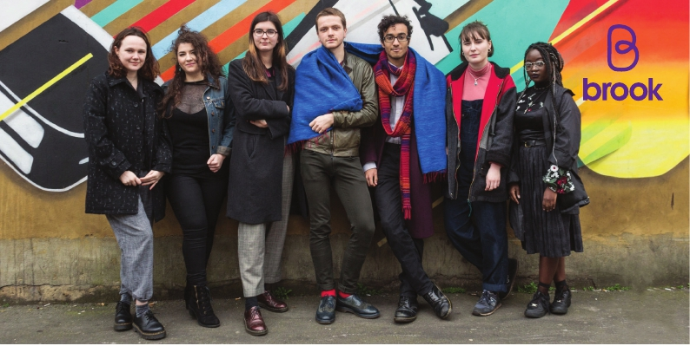

**BROOK RSE@HOME**

**Digital Booklet**

**October 2021**

Introduction

Hi everyone and thanks for joining our Facebook Live session. Unfortunately, we faced quite a few technical issues during this session and so I have added the information from that live into this document.

Facebook live sessions are aimed at local parents of secondary school age children and young people. We mainly discuss the Essex area but are aware that parents from Southend and Thurrock might have joined us as well. If you are from one of the surrounding areas and want more localised signposting information please do contact us. You can also contact us for support with how to make a request for support with your local safeguarding board if needed.

Also, make sure you take care of yourself and take a step back at any time if you find the session is impacting you.

My name is (**XXXX)** and I work for Brook across Southend, Essex and Thurrock. I am a Health Promotion Coordinator in our Southend team. Within Southend I work within our all-age sexual health service alongside our clinical team. We deliver information and advice in a variety of ways, such as outreach and online, highlighting our ‘digital front door’ to the service. Within Essex and Thurrock, our team is much more young people focussed, collaborating with the local sexual health services, offering 1:1 wellbeing support, relationship and sex education (RSE) sessions, professional training and parent sessions, which is why I am here today.

Nationally, our team also supports Brooks continuing innovative work, up and down the country. Further adding to the, almost, 60 years’ experience we have in the sexual health and wellbeing sector.

**Why are we here?**

To give parents and carers an understanding of what RSE lessons at school will be covering, as well as equipping you with practical tools and knowledge to broach these subjects at home. Today we will specifically be focussing in on how to ensure SEND children and young people are receiving a comprehensive and inclusive RSE however, a lot of what we are going to talk about today isn’t strictly SEND focused. This Facebook live is aimed at how you can support this as a parent or carer. If you would like any further information or support you can always email our team at [essex.education@brook.org.uk](mailto:essex.education@brook.org.uk). My colleague will put this email address in the comments as well.

We will be running a course of 4 Facebook live sessions for Parents/carers, alongside Essex Safeguarding Children Board, plus a series of podcasts for young people. This will equip yourselves with practical tools and knowledge to broach these subjects at home. This week we are running things slightly different however. In place of a podcast we are offering parents and carers a digital booklet filled with relevant local and national resources and signposting for young people with SEND. To receive this booklet, please email us at the address mentioned earlier.

If you want to get involved with the discussion around this or future topics with Brook, you might like to look at our social media:

**Instagram: brook_sexpositive**

**Website:** [**brook.org.uk**](http://www.brook.org.uk)

**Twitter @brookcharity**

**Plus our more local Facebook pages such as @EssexBrook and @SouthendSexualHealthServiceViaBrook**

The way these lives work are we answer some commonly asked questions based on what we are asked often by parents. Then we will take a few questions live in the last section of the live.

**Everyone parents differently**

There are many factors which affect how we parent for example our own family values, how we were raised, and our life experiences.

In Brook, whenever we do sessions or workshops we prepare a Brook space, which is a safe, non-judgemental space to learn. I’d like this live to also work as a Brook space today, so let’s make sure we’re not judging other people’s attitudes or approaches to parenting. We’re all different, and we’re all in this space to learn.

Be aware of different parent choices at all times. There is not one way to have these conversations nor is there one way of parenting – we are all different and have different experiences. This will shape the way we have these conversations with our children.

**What is the schools role?**

Schools now have a mandatory duty to teach Relationships and Sex Education. And more information about this can be found on the [Government’s guide for secondary school parents](https://assets.publishing.service.gov.uk/government/uploads/system/uploads/attachment_data/file/812594/RSE_secondary_schools_guide_for_parents.pdf).

Schools and colleges also have a duty to tackle bullying and sexual harassment in schools and the government provided advice for schools and colleges on how to prevent and respond to reports of sexual violence and harassment between children and consent can play a major role here. Please note, SEND, or special education settings, will likely deliver RSE slightly differently. This is because the setting will teach RSE at an age and stage appropriate level. What has worked for one group of young people might not for another and vice versa. Therefore, many SEND schools will have a curriculum but will utilise differentiation, or the need to adapt based on the learners needs.

**What if my child or young person discloses harm?**

Comprehensive relationships and sex education could support someone to recognize if they have experienced some form of harm. They might feel safe there and then in school to talk to a teacher, and the school will follow their safeguarding policy. If you contact the school your child/young person attends, they should be able to get this across to you, but it may also be available on their website.

They might also come to you for help. Of course, the idea of any child or young person disclosing abuse is distressing, but the way it is handled will support the child’s recovery and healing processes.

The [NSPCC provides advice](https://www.nspcc.org.uk/keeping-children-safe/reporting-abuse/what-to-do-child-reveals-abuse/) about how to respond and speak to a child who reveals abuse. Ultimately listening, reassuring them they have done the right thing in telling you and it is not their fault, explain what’s going to happen next. You’ll also need to report what has happened as quickly as you can, while the details are fresh in your mind. Don’t confront the alleged abuser as this could make the situation worse. [Contact the NSPCC](https://www.nspcc.org.uk/keeping-children-safe/reporting-abuse/what-to-do-child-reveals-abuse/) if you need to report abuse.

It might feel worrying reporting what has happened but professionals are there to support you and the child, helping you through the next steps.

If a child is in immediate danger call the police on 999 straight away.

**Ok, now we are going to go through some examples of questions we have been asked in previous Parent RSE sessions…**

1. **“When is the right time to start discussions around sex and relationships?”**

Follow your child or young person’s lead. If they are feeling that their question is important enough to ask, then this should be the right time to answer them in an appropriate manner. If they are unable to fully verbally communicate their desire to find out more, we can be led by non-verbal communication too; for example, are they showing an interest in their own bodies or that of others.

Also, don’t panic! We don’t always know all the answers and it can be a really good opportunity for us to broaden our own understanding. Having a ‘safe google’ can be really helpful (just be really aware of what you are goggling) and head over to reputable sources, such as ourselves, Brook.org.uk, and Mencap. The important thing to remember is that they trust you enough to ask the questions!

It can sometimes feel overwhelming as parents and carers; that we don’t want to answer questions incorrectly, at the wrong time or “put ideas in their heads” but taking an age and stage appropriate approach can be really healthy and lead to happy conversations about important life experiences, preparing them for a fulfilling adult life.

Brook believes that every young person has equal rights to express their own sexuality and gender, and they should have the same access to RSE. This does not mean that it’s a ‘one size fits all’ approach to RSE, but tailoring the discussion to meet the needs and understanding of your children and young people.

1. **“What should be discussed?”**

Again, as parents and carers, follow the lead of your child or young person. If your young person attends a school or setting, they may be able to advise on what topics they are currently covering, and offer further guidance on what you could discuss at home.

Within schools and settings, they will be following RSE government guidelines. Education will be offered on consent, anatomy, puberty, and healthy relationships, amongst many other topics. Under the government guidelines, it states to ‘tailor content to keep it appropriate for those participating’ and content should be accessible for all. Schools and settings should be aware that some pupils are more vulnerable to exploitation, bullying and other issues due to the nature of their SEND. RSE can be an amazing tool to help safeguard and protect our children and young people. For example, the topic of appropriate touch can be really helpful and allow children and young people to understand what is safe and healthy, especially when they may be having personal care, and who they can turn to if support is needed.

Language is really important! For example, correct terminology should be given to penis, testicles, vulva and vagina. This may feel uncomfortable at first, as we may be more used to calling genitals by things such as ‘willy’ or ‘noonie’, but giving the correct name can again aid towards safeguarding, and also give them a good starting point for future discussions on contraception and STI’s.

1. **How can I support my child or young person through navigating relationships?**

Talk openly about relationships and the different types of them. Discuss families, friends, sexual relationships, professionals, and carers, and realistic expectations. Explain how relationships may change and how we may be attracted to someone but that they may not be attracted to us in return – speaking about rejection and how that can make us feel is an important part of recognising a healthy relationship.

1. **“I am worried that my child may be showing inappropriate sexualised behaviour, what can I do?”**

Firstly, take time to reflect on the behaviour.

It may be an act that would be deemed sexualised, from the undertones we see as an adult, but the child or young person may be doing it as a ‘comfort’. They may be doing the behaviour as a way to feel safe and calming within themselves, and it will be down to those adults around them to make sure they are safe, and that others witnessing the behaviour are also safe. This can be a great opportunity to discuss public and private places, that it’s fine to explore our own bodies but in a private manner. This could be done through a verbal discussion, social story board or visual prompts, such as a video; using the most appropriate mode for your young person.

Also, make sure you link up with their school or setting. A consistent message across home and school can be really beneficial and aid towards that cohesive and comprehensive RSE that young people deserve.

**I feel like I may be repeating myself here, but the key factors are to follow the lead of your young person. Keep it appropriate and in a timely manner, ensuring that topics are covered before the need arises – so broaching topics like puberty before puberty begins. Reach out to organisations and settings that support your child or young person, and see what they are covering and how you can continue that education at home.**

**Some helpful resources could be:**

* You can increase your knowledge through [Brook Learn](https://www.brook.org.uk/brook-learn/) offering free e-learning and free resources including consent
* Sexual Health Week for 2019 was focused upon Sex, Disabilities and Relationships, with a load of resources, articles and discussion points. Our Sexual Expression professional pack includes topics on wet dreams, masturbation and healthy relationships.
* Brook also has a [YouTube channel](https://www.youtube.com/channel/UCdUFbzwPyQg77O4i_vWvG5g) with videos made by young people explaining topics such as consent

**If anyone does have any questions, we can happily answer them now. Or please do feel free to get in contact with us directly on** [**essex.education@brook.org.uk**](mailto:essex.education@brook.org.uk) **(we will pop that in the chat below again)**

**If no one does have any questions, we just really want to thank you for joining us today and look forward to seeing you on our next one. Make sure you like and follow our Southend and Essex facebook pages, to keep up to date with all we are doing.**

This report provides an overview of the work completed by Brook’s Education team in Thurrock in Quarter 1 (April to June 2021) and highlights some of our national and local successes and innovations during this time. The commentary illustrates the scope and nature of education work undertaken and provides evidence of the ways service provision makes a real difference to the lives of vulnerable young people.

Brook has been putting young people’s health and wellbeing first for 50 years, often swimming against the tide, but always putting young people front and centre. Our vision is that young people’s lives are free from inequality, rich with opportunity and enriched by happy, healthy relationships. Brook is the only national charity to offer both clinical sexual health and education and wellbeing services for young people.

What is the school’s role?

Schools now have a mandatory duty to teach Relationships and Sex Education. And more information about this can be found on the [Government’s guide for secondary school parents](https://assets.publishing.service.gov.uk/government/uploads/system/uploads/attachment_data/file/812594/RSE_secondary_schools_guide_for_parents.pdf).

Schools and colleges also have a duty to tackle bullying and sexual harassment in schools and the government provided advice for schools and colleges on how to prevent and respond to reports of sexual violence and harassment between children and consent can play a major role here. Please note, SEND, or special education settings, will likely deliver RSE slightly differently. This is because the setting will teach RSE at an age and stage appropriate level. What has worked for one group of young people might not for another and vice versa. Therefore, many SEND schools will have a curriculum but will utilise differentiation, or the need to adapt based on the learners needs.

What if my child or young person discloses harm?

Comprehensive relationships and sex education could support someone to recognize if they have experienced some form of harm. They might feel safe in school and talk to a teacher, and the school will follow their safeguarding policy. If you contact the school your child/young person attends, they should be able to get this across to you, but it may also be available on their website.

They might also come to you for help. Of course, the idea of any child or young person disclosing abuse is distressing, but the way it is handled will support the child’s recovery and healing processes.

The [NSPCC provides advice](https://www.nspcc.org.uk/keeping-children-safe/reporting-abuse/what-to-do-child-reveals-abuse/) about how to respond and speak to a child who reveals abuse. Ultimately listening, reassuring them they have done the right thing in telling you and it is not their fault, explain what’s going to happen next. You’ll also need to report what has happened as quickly as you can, while the details are fresh in your mind. Don’t confront the alleged abuser as this could make the situation worse. [Contact the NSPCC](https://www.nspcc.org.uk/keeping-children-safe/reporting-abuse/what-to-do-child-reveals-abuse/) if you need to report abuse.

It might feel worrying reporting what has happened but professionals are there to support you and the child, helping you through the next steps.

If a child is in immediate danger call the police on 999 straight away.

During August, Brook Thurrock will be running various social media campaigns aimed at Parents, talking about local services and where to access support. We will also continue to advertise our national Facebook Live sessions.

Common questions

**“When is the right time to start discussions around sex and relationships?”**

Follow your child or young person’s lead. If they are feeling that their question is important enough to ask, then this should be the right time to answer them in an appropriate manner. If they are unable to verbally communicate their desire to find out more, we can be led by non-verbal communication too; for example, are they showing an interest in their own bodies or that of others.

Also, don’t panic! We do not always know all the answers and it can be a really good opportunity for us to broaden our own understanding. Having a ‘safe google’ can be helpful (just be really aware of what you are googling) and head over to reputable sources, such as ourselves, [**Brook.org.uk**](http://www.brook.org.uk/), and [**Mencap**](https://www.mencap.org.uk/). The important thing to remember is that they trust you enough to ask the questions!

It can sometimes feel overwhelming as parents and carers; that we do not want to answer questions incorrectly, at the wrong time or “put ideas in their heads” but taking an age and stage appropriate approach can be really healthy and lead to happy conversations about important life experiences, preparing them for a fulfilling adult life.

Brook believes that every young person has equal rights to express their own sexuality and gender, and they should have the same access to RSE. This does not mean that it’s a ‘one size fits all’ approach to RSE, but tailoring the discussion to meet the needs and understanding of your children and young people.

**“What should be discussed?”**

Again, as parents and carers, follow the lead of your child or young person. If your young person attends a school or setting, they may be able to advise on what topics they are currently covering, and offer further guidance on what you could discuss at home.

Within schools and settings, they will be following RSE government guidelines. Education will be offered on consent, anatomy, puberty, and healthy relationships, amongst many other topics. Under the government guidelines, it states to ‘tailor content to keep it appropriate for those participating’ and content should be accessible for all. Schools and settings should be aware that some pupils are more vulnerable to exploitation, bullying and other issues due to the nature of their SEND. RSE can be an amazing tool to help safeguard and protect our children and young people. For example, the topic of appropriate touch can be really helpful and allow children and young people to understand what is safe and healthy, especially when they may be having personal care, and who they can turn to if support is needed.

Language is really important! For example, correct terminology should be given to penis, testicles, vulva and vagina. This may feel uncomfortable at first, as we may be more used to calling genitals by things such as ‘willy’ or ‘noonie’, but giving the correct name can again aid towards safeguarding, and also give them a good starting point for future discussions on contraception and STI’s.

1. **How can I support my child or young person through navigating relationships?**

Talk openly about relationships and the different types of them. Discuss families, friends, sexual relationships, professionals, and carers, and realistic expectations. Explain how relationships may change and how we may be attracted to someone but that they may not be attracted to us in return – speaking about rejection and how that can make us feel is an important part of recognising a healthy relationship.

1. **“I am worried that my child may be showing inappropriate sexualised behaviour, what can I do?”**

Firstly, take time to reflect on the behaviour.

It may be an act that would be deemed sexualised, from the undertones we see as an adult, but the child or young person may be doing it as a ‘comfort’. They may be doing the behaviour as a way to feel safe and calming within themselves, and it will be down to those adults around them to make sure they are safe, and that others witnessing the behaviour are also safe. This can be a great opportunity to discuss public and private places, that it’s fine to explore our own bodies but in a private manner. This could be done through a verbal discussion, social story board or visual prompts, such as a video; using the most appropriate mode for your young person.

Also, make sure you link up with their school or setting. A consistent message across home and school can be really beneficial and aid towards that cohesive and comprehensive RSE that young people deserve.

As schools returned, we saw an increase in both bookings and cancellations in the Thurrock area. Understandably, schools had to either close entirely or restrict certain year groups and ‘bubbles’ from attending. This has had a significant impact on young people’s sexual health, mental wellbeing and social development. It has also significantly hindered Brook’s ability to deliver upon KPIs, given that so much of our work is schools-based.

The return of schools was welcome but did not allowed Brook to resume its usual activity.

During lockdown, Brook prioritised:

* Continuing all of our 1:1 work over the telephone, supporting particularly vulnerable young people.
* Regularly checking in with all young people who remain on our safeguarding registers and signposting them to services as and when needed.
* Working with schools where appropriate to support them in their wellbeing check-ins with young people.
* Offering schools digital sessions for the children of key workers who were still in school.

appropriate touch can be really helpful and allow children and young people to understand what is safe and healthy, especially when they may be having personal care, and who they can turn to if support is needed.

Language is really important! For example, correct terminology should be used, for example, penis, testicles, vulva and vagina. This may feel uncomfortable at first, as we may be more used to calling genitals by slang terms, but giving the correct name can again aid towards safeguarding, and also give them a good starting point for future discussions on contraception and STI’s.

**“How can I support my child or young person through navigating relationships?”**

Talk openly about relationships and the different types of them. Discuss families, friends, sexual relationships, professionals, and carers, and realistic expectations. Explain how relationships may change and how we may be attracted to someone but that they may not be attracted to us in return – speaking about rejection and how that can make us feel is an important part of recognising a healthy relationship.

**“I am worried that my child may be showing inappropriate sexualised behaviour, what can I do?”**

Firstly, take time to reflect on the behaviour.

It may be an act that would be deemed sexualised, from the undertones we see as an adult, but the child or young person may be doing it as a ‘comfort’. They may be doing the behaviour as a way to feel safe and calming within themselves, and it will be down to those adults around them to make sure they are safe, and that others witnessing the behaviour are also safe. This can be a great opportunity to discuss public and private places, that it’s fine to explore our own bodies but in a private manner. This could be done through a verbal discussion, social story board or visual prompts, such as a video; using the most appropriate mode for your young person.

Also, make sure you link up with their school or setting. A consistent message across home and school can be really beneficial and aid towards that cohesive and comprehensive RSE that young people deserve.

* Arranged approx. **32** educational sessions for young people in schools and educational organisations across Thurrock, which would have equated to the delivery of RSE education to approx. **783** young people. Unfortunately, sessions were cancelled due to the ongoing impact of COVID-19.
* **7** Education sessions cancelled due to COVID-19.
* **1** professionals training session cancelled due to COVID-19 and cancellations from participants.

For more information and support about any of the information discussed within the live session or this document, please contact us at [essex.education@brook.org.uk](mailto:essex.education@brook.org.uk)

You can increase your knowledge through [Brook Learn](https://www.brook.org.uk/brook-learn/) offering free e-learning and free resources including consent

Sexual Health Week for 2019 was focused upon Sex, Disabilities and Relationships, with a load of resources, articles and discussion points. Our Sexual Expression professional pack includes topics on wet dreams, masturbation and healthy relationships.

Brook also has a [YouTube channel](https://www.youtube.com/channel/UCdUFbzwPyQg77O4i_vWvG5g) with videos made by young people explaining topics such as consent

Please the next page for more signposting and resources information.

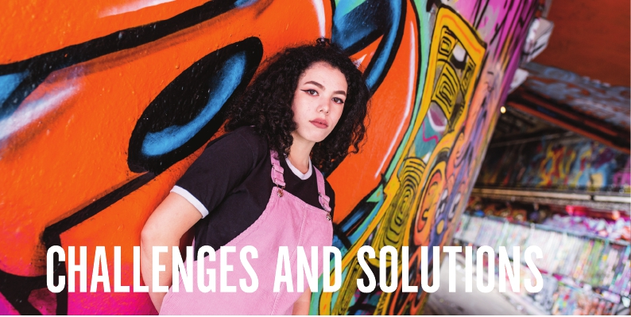

Please note, some of these will not be appropriate for all ages and the content might have changed or been updated. Below is a range of resources and signposting information. If there is a local organisation that we have missed or one that you want to champion, please do email us at [essex.education@brook.org.uk](mailto:essex.education@brook.org.uk)

* [**Mencap**](http://www.mencap.co.uk)

**On the website you will find videos, articles and resources developed with Brook for Sexual Health Week 2019.**

* [SNAP](https://www.snapcharity.org/) (local)

If you have a child between 0 – 25 years who has any special need or disability and you live in Essex, SNAP are here for you and your family.

No formal diagnosis or professional referral is necessary to access SNAP services.

* [**Open University Sexuality Alliance**](https://www.open.ac.uk/health-and-social-care/research/sexuality-alliance/about-sexuality-alliance)

**Open University Sexuality Alliance have a booklet aimed at young people about how to discuss sex and intimacy.**

* [Enhance the UK](https://enhancetheuk.org/)

Run by disabled people, for disabled people. With podcasts, ebooks and training sessions, Enhance the UK aims to change the way disability is viewed for the better.

* [**Easy on the i**](https://www.learningdisabilityservice-leeds.nhs.uk/easy-on-the-i/)

**Easy on the i has a range of images to support story/social boards. These images are free to downloads and can help support children and young people as a visual aid. If you cannot find a particular image, you can also request a new one!**

Resources and signposting

* [Hannah Witton](http://www.hannahwitton.com)

On Hannah’s website you will find blogs about body positivity as well as videos and blogs. Not suitable for primary aged children.

* **Autism Friendly guide to periods by Robyn Steward**

**This book has had some great reviews and might be worth checking out.**

* [Brook Sexual Expressions pack](https://legacy.brook.org.uk/attachments/Sexual_Expression_Resource.pdf)

A relationships and sex education (RSE) resource for people with learning difficulties and disabilities free to download

* [**Brook and MENCAP**](https://legacy.brook.org.uk/attachments/Guide_for_families_BrookMencap.pdf)

**Talking about sex, relationships and sexual health with any young person can be daunting. When the person you are talking to has a learning disability, it can be even more complex, but remains just as important to ensure their understanding of their bodies, health and relationships. Brook and Mencap created this free downloadable guide for parents and carers’.**

* Worried about Internet Safety and Security as a parent or carer? Check out this short video about online privacy <https://youtu.be/yiKeLOKc1tw>
* **The** [**Essex Safeguarding Children Board website**](https://eur02.safelinks.protection.outlook.com/?url=https%3A%2F%2Fwww.escb.co.uk%2Fcampaigns%2Fonline-safety%2F&data=04%7C01%7C%7Cb3a48e3663404fa8b79e08d942ed2858%7Ca8b4324f155c4215a0f17ed8cc9a992f%7C0%7C1%7C637614409941847369%7CUnknown%7CTWFpbGZsb3d8eyJWIjoiMC4wLjAwMDAiLCJQIjoiV2luMzIiLCJBTiI6Ik1haWwiLCJXVCI6Mn0%3D%7C2000&sdata=aJ%2B38TJkggxTE0nBbb9Rf3pWDZQrRC3dSrZIgtU0cFs%3D&reserved=0) **has resources for parents and carers as well as professionals to support children and parents. There’s loads of info just a few clicks away!**
* What if Goldilocks had a mobile phone? Listen to the story online at <https://youtu.be/HOqQou75Cxc>
* **Worried about Minecraft and how your child/young person can stay safe while playing with friends online? Check out this post with loads of safety tips** [**https://thecybersafetylady.com.au/2014/08/a-parents-guide-to-minecraft/**](https://thecybersafetylady.com.au/2014/08/a-parents-guide-to-minecraft/)
* Film for parents and carers- The Essex Child & Family Wellbeing Service have produced a new video aimed at new parents and you can watch it at <https://essexfamilywellbeing.co.uk/service/antenatal-session-virtual-guided-support/>
* **Brook has a dedicated page about Staying Safe Online? Head to** [**www.brook.org.uk/topics/staying-safe-online/**](http://www.brook.org.uk/topics/staying-safe-online/) **for info on Cyber Bullying, Sexting and Selfies, Online Dating & Staying Safe as well as our Online Dating Glossary.**
* Sharing images is a concern for many, especially for parents of children and young people. #Do you know how to go about having nudes shared online removed? More info at <https://www.childline.org.uk/info-advice/bullying-abuse-safety/online-mobile-safety/remove-nude-image-shared-online/>
* RSE@Home is a series of Facebook live sessions for parents and carers. With FAQ’s and further support, [click here](https://www.facebook.com/watch/live/?v=271066730953052&ref=watch_permalink) to check out our session on contraception
* **The**[**AFC Crisis Messenge**](https://www.annafreud.org/on-my-mind/afc-crisis-messenger/)**r text service provides free, 24/7 crisis support for young people across the UK.  If you are experiencing a mental health crisis and need support, you can text AFC to 85258.**
* Have you heard about the ec-card app? It’s free to download and once signed up young people can access free condoms. [click here](https://www.essexsexualhealthservice.org.uk/modules/downloads/download.php?file_name=69) for more info
* **The Training Effect produced a video for parents that provides some hints and tips on how you can support your children to stay safe.** [**watch the video here**](https://youtu.be/4fYYA-z2xHU)
* Have you seen the Digital Resilience toolkit online? Internet Matters has loads of video to support with online safety [available here](https://www.internetmatters.org/resources/digital-resilience-toolkit/)
* **Brook's Sex Ed Diaries, is a podcast about Relationships and Sex Education in schools. Head to** [**www.sexeddiaries.org/**](http://www.sexeddiaries.org/) **to listen to the episodes and for more information about our guests.**
* It’s really important that young people have all the tools available to make informed decisions. Here’s what to expect when attending clinic [in a short video](https://youtu.be/TT1Qo2qEPRk)
* **During one of our Facebook live sessions we talk about Mental Health. Check it out for common questions and our response on** [**our Facebook page**](https://www.facebook.com/BrookCharityYP/videos/rse-at-home-with-brook-mental-health/496613241539698/)
* Do you have a child or young person that excels in online technology? Want them to learn and be informed about cyber choices? There’s a resource for that at <https://nationalcrimeagency.gov.uk/what-we-do/crime-threats/cyber-crime/cyberchoices>
* **Brook has some amazing advice, articles and resources to support discussions and education about puberty? Jump over to** [**www.brook.org.uk/your-life/puberty/**](http://www.brook.org.uk/your-life/puberty/) **to see what @BrookCharity is talking about!**
* **Brook has a dedicated page about Staying Safe Online? Head to** [**www.brook.org.uk/topics/staying-safe-online/**](http://www.brook.org.uk/topics/staying-safe-online/) **for info on Cyber Bullying, Sexting and Selfies, Online Dating & Staying Safe as well as our Online Dating Glossary.**

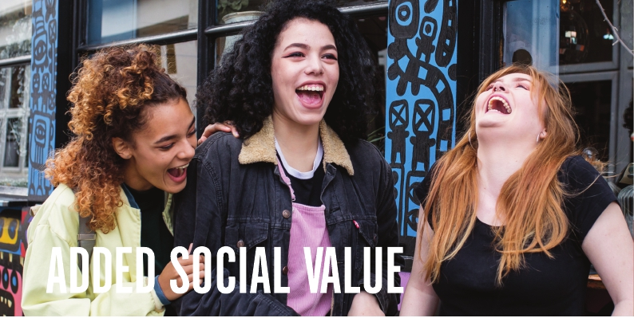

* **Parents and Carers- Think B4 You Type is a free toolkit to help you support your secondary school-aged children and young people to design & lead their own campaign around online bullying** [**Click here to access the toolkit**](https://eur03.safelinks.protection.outlook.com/?url=https%3A%2F%2Flearning.nspcc.org.uk%2Fresearch-resources%2Fschools%2Fanti-bullying-campaign-toolkit&data=04%7C01%7CJennie.Read%40essex.police.uk%7Cc7f58ffa8e2a4c0075c308d92f22f2e6%7Cf31b07f09cf940db964d6ff986a97e3d%7C0%7C0%7C637592649460338655%7CUnknown%7CTWFpbGZsb3d8eyJWIjoiMC4wLjAwMDAiLCJQIjoiV2luMzIiLCJBTiI6Ik1haWwiLCJXVCI6Mn0%3D%7C1000&sdata=%2B8vY9Z5j9y3Qocl4w7cXCwJoyIyDqtAzrMWAci9SB0I%3D&reserved=0)
* Free digital resources have been developed to provide advice and guidance to parents and carers supporting a child or young person who may be struggling with poor mental health Check them out at <https://www.annafreud.org/msm/>
* **Worried about Relationship and Sex Education? Not sure what is going to be taught and when? Check out our Facebook live about Mandatory RSE on** [**our Facebook page**](https://sw-ke.facebook.com/BrookCharityYP/videos/rse-at-home-with-brook-mandatory-rse/333269727790839/)
* Twisted toys is a resource that parents can use to look at online dangers as physical ones by presenting them as traditional toys, check them out at <https://twisted-toys.com/>
* **Thinkuknow has a brand new resource to support *Send me a pic?* Is available at** [**https://www.thinkuknow.co.uk/professionals/resources/send-me-a-pic**](https://www.thinkuknow.co.uk/professionals/resources/send-me-a-pic)
* Film for parents and carers- The Essex Child & Family Wellbeing Service have produced a new video aimed at new parents and you can watch it at <https://essexfamilywellbeing.co.uk/service/antenatal-session-virtual-guided-support/>
* **The Essex Safeguarding Children Board website has resources for parents and carers as well as professionals to support children and parents. There’s loads of info just a few clicks away!**

We are constantly checking for new resources to support parents and carers’, if there is something we have missed or a resource you would recommend please let us know at [essex.education@brook.org.uk](mailto:essex.education@brook.org.uk)