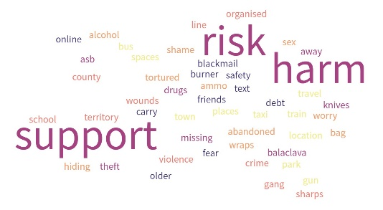
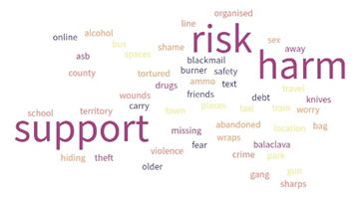

Risk in the Community Briefing for young person
- I work in the Involvement Team which is independent from social care and so I do not know what is happening for you other than worries people have when you are not at home.

- I am here to talk to you about how life is for you when you are out with friends and in local spaces. It is important for me to understand your thoughts and feelings so that we can understand what you feel is safe/unsafe and how we can keep you safe.

- I will ask you about times when you are out of your home or online and worries others have for you. We will talk about the reasons people may worry and about things that may help you feel supported to be safe.

- I appreciate that this can be difficult to talk about sometimes and you don’t have to tell me anything you’re uncomfortable with, but I am here to support you.

- There are no right or wrong answers; this is a discussion where you can give your views openly and honestly.

- I will make notes on what you say so that I don’t miss anything important. I will put these notes on your case file and share with your social worker and other professionals if I need to.

- I can’t guarantee what will or won’t happen following our chat, but I will be honest with you and tell you what I am going to do next.

- If you tell me something that makes me worried that you or anyone else is not safe, I will tell the social work team who may contact you about it.

- Our team will combine your views with what other young people say about their life in the community, and peer relationships, to help us understand what would make things better for young people. What you tell me today is anonymous which means your name will not be mentioned and no one will be able to identify you.

- This is a voluntary activity which means you do not have to take part if you do not want to and you can let me know at any time if you want to finish the discussion.

